|  |  |  |
| --- | --- | --- |
| **213** | THE GRILL | **213** |

**A REAL HISTORIC PUB WITH**

**A UNIQUE WELCOME**

Centrally located, close to the Theatre,

Aberdeen Music Hall and many restaurants.

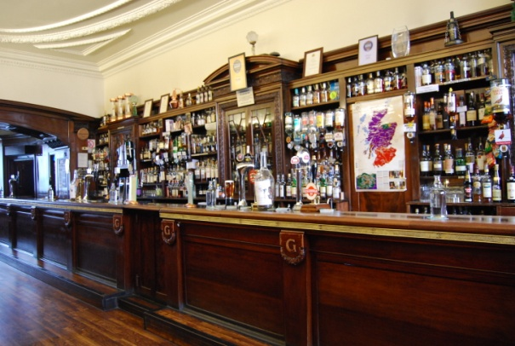

**Select from a superb range of over**

**600 whiskies and rums**

**from around the world.**

**Try one of our popular Whisky Flights.**

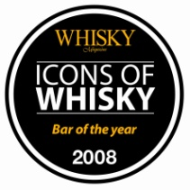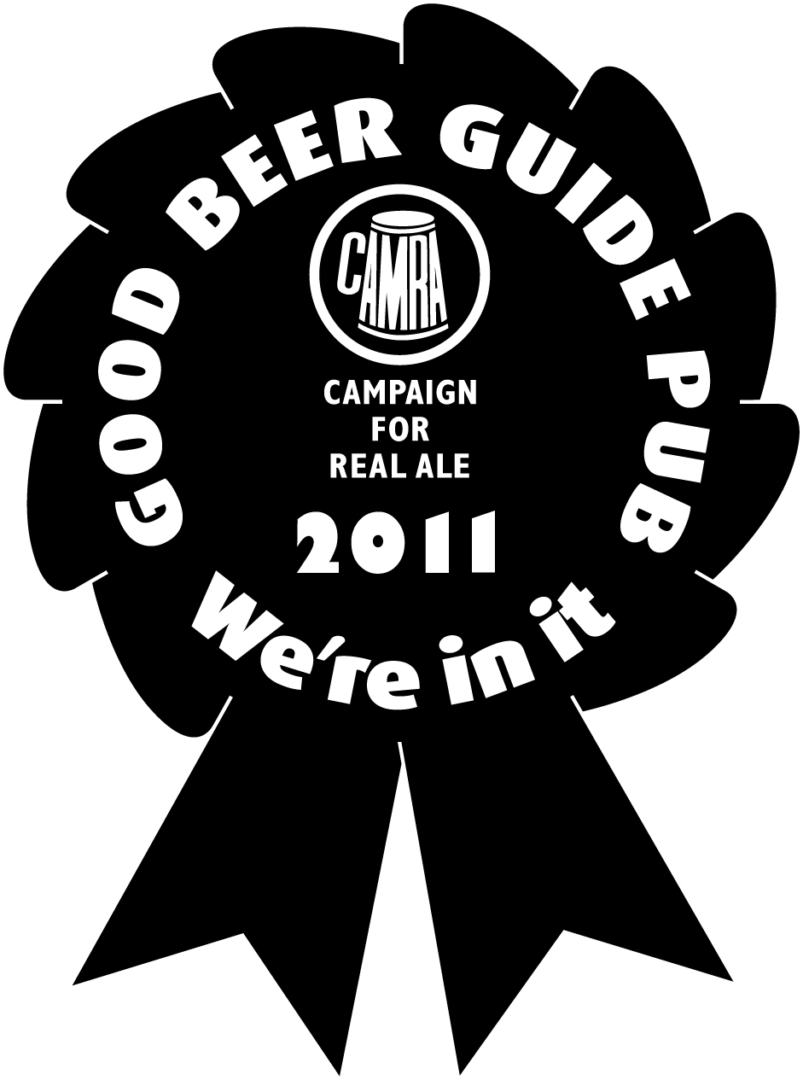

Open 10am-midnight

(1am Fridays & Saturdays)

Sundays 12.30-midnight

213 Union Street Aberdeen AB11 6BA

Tel.01224 573530

www.thegrillaberdeen.co.uk